**The unexpected Jesus**

**Reading:** from Mark 2:1-12

A few days later, Jesus entered Capernaum again. the people heard that he had come home. So many people gathered that there was no room left. There was not even room outside the door. Four of those who came were carrying a man who could not walk. But they could not get close to Jesus because of the crowd. So they made a hole by digging through the roof above Jesus. Then they lowered the man through it on a mat. Jesus saw their faith. So he said to the man, “Son, your sins are forgiven.”

Some teachers of the law were sitting there. They were thinking, “Why is this fellow talking like that? He’s saying a very evil thing! Only God can forgive sins!”

Jesus said to them, “I want you to know that the Son of Man has authority on earth to forgive sins.” So Jesus spoke to the man who could walk. “I tell you,” he said, “get up. Take your mat and go home.” The man got up and took his mat. Then he walked away while everyone was watched. All the people were amazed. They praised God and said, “We have never seen anything like this!”

**Thought about the reading**

Why do we believe that Christianity is true? The reason is Jesus himself. When we read the stories about him in the Bible, we learn who he is and what he is like.

In the story today, we learn that Jesus does not always behave the way people think he should. Everyone in the crowd must have thought he would heal the man who could not walk. But the first thing he did was to tell the man that his sins were forgiven! The teachers of the law were shocked! They believed that only God could forgive sins. How could Jesus do that?

Jesus is the Son of God. God is his father. Although he is a human like any of us, he is also God. That is why he can forgive our sins when we say we are sorry. That is why he was able to forgive the man who could not walk and was also able to make him better.

**Prayer**

Dear Jesus, thank you that you are able to forgive all the wrong things I have done. I am sorry and I ask you to forgive me.

Please help me to follow you.

Amen

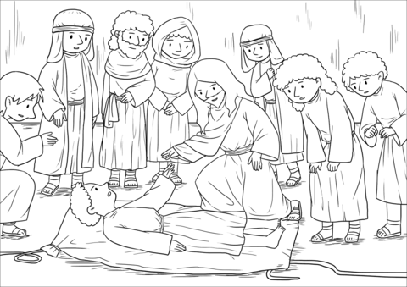

**Cambridge Causeway**

Autumn 2025

Bible Study notes

**Jesus the reason**

**1.The unexpected Jesus**

By Chrissy Cole